

Twentieth Sunday after Pentecost

Sunday, October 6, 2024

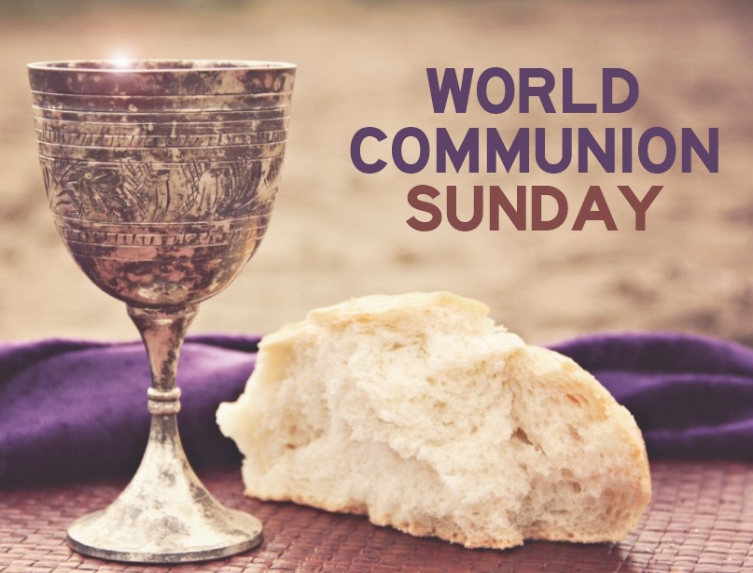

Welcome and Announcements ☨ Trinity is Welcoming, Open,

Inclusive and Accessible. ‒ Trinity is an Affirming Congregation

☨ Our building is open 9:00 am to 1:00 pm, Monday through Thursday (Closed on Statutory Holidays)

**A Congregational Meeting will be held today, immediately following the service to receive the recommendation of the Ministerial Search Team.**

**Trinity welcomes** Rev. Matt Gallinger as our guest speaker this morning.

**Please join us for Social Time After Church in the Fellowship Hall –** If you wish to volunteer to help with Social time, the sign-up sheet is on the bulletin board.  Individuals or groups are invited to sign-up.

**Are you having trouble hearing the service?**  Trinity has listening devices for you to use here.  Just ask Cory at the sound booth for one and he will gladly explain how to use it.

**In person Sunday School** is the 2nd and last Sunday of each month.

**Please Assist the UCW with the Fellowship of the Least Coin**. We have placed a fishbowl at the back of the sanctuary to receive your gifts.

**UCW Meeting –** Monday, October 7th. Gather at 9:00 and meeting starts at 9:30 a.m. Chair yoga will meet following UCW starting at 12:00 noon.

**Smiths Falls Community Food Bank** appreciates donations.

**Harvest Supper – Saturday, October 19th** – Doors open at 5 p.m. and meal will be served at 5:30 p.m. Tickets will be on sale following Sunday services starting today, and at the church office during open hours Monday to Thursday, until they are sold out. Cost is $22 per plate, children 6 to 10 years are $10 and under 5 years is free.

**Holly Fair – Saturday, November 2** – 10 am to 1 pm at Trinity United. Come and purchase your baking, crafts, jams, preserves, homemade knits/crochet, have a coffee and a treat and so much more!

**Christmas Wreath Sale –** Orders will be taken from September 30th to November 20th. Pick up date is at Trinity on November 28th at 1:15 pm. To order your wreath, contact Linda Zieman 613-283-2728 (leave a message) or the Church Office at 613-283-4444.

**Van Horne Monthly Service – Begins again on Tuesday, November 5th at 2 p.m.** UCW will have coffee/tea time with the ladies following the service.

**Save the date! More information in the coming weeks.**

Tripoly and the Grenville Troubadours – December 13

**Introit:** MV 173 “Put Peace into Each Other’s Hands” (vs. 1, 5a)

**Acknowledging Traditional Territory**

**Call to Worship:**

**Opening Prayer**:

**Hymn:** VU 477 "I Come with Joy"

**Prayer of Understanding:**

**Scriptures:** Genesis 2:18-24, Mark 10:2-16 (NRSV)

**Anthem:** “Glory to God” (arr. Law)

**Reflection:** Rev. Matt Gallinger

**Hymn:** VU 341 “Fairest Lord Jesus”

**Prayer for a renewal of our shared humanity:** *(General Council office of the United Church of Canada)*  
**Liturgical Response for October 7**  
  
**Offering Options**

○ E-transfers to [secretary@trinityunitedsf.ca](mailto:secretary@trinityunitedsf.ca)

○ delivery to church office

○ through Trinity website DONATE button

○ PAR

**Offering Prayer**

**Hymn:** MV 82 “Bathe Me in Your Light”

**Communion**

**Statement of Faith:** VU 918 A New Creed

**Great Prayer of Thanksgiving:**

**The Lord’s Prayer (In Unison)**

**Invitation**

**Breaking and Sharing**

**Prayer after Communion:**

**Hymn:** VU 481 “Sent Forth by God’s Blessing”

**Commissioning and Benediction:**

**Choral Amen**

*(All hymns reproduced with permission under license # A-735850 One License)*